*FOR RELEASE (Date and time)*
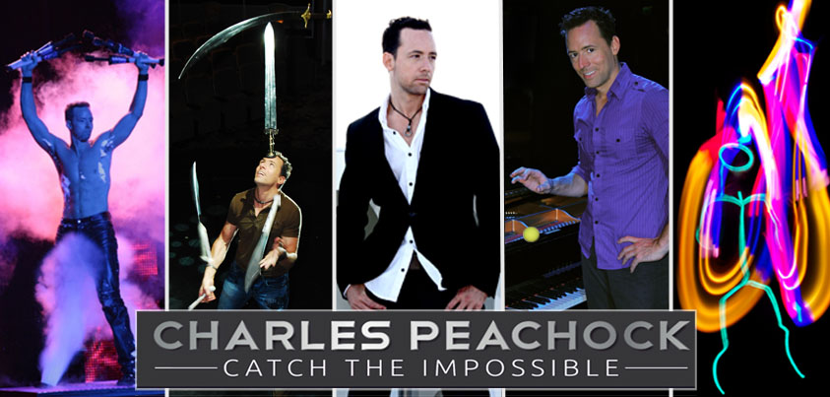
CAPTIVATING COMEDY JUGGLER IS REWRITING THE RULES OF HIS ART FORM. AFTER A RECORD BREAKING RUN ON AMERICA’S GOT TALENT HE’S HITTING ROAD ON A NORTH AMERICAN TOUR.
This is a family friendly show but it is NOT a children’s show.

Prepare to be doubled over in laughter as Comedian Charles who is a finalist from the highly acclaimed television sensation America’s Got Talent, showcases his extraordinary talents like never before.

Defying expectations or a “juggling act”, Charles shattered records during his unforgettable journey on America’s Got talent, surpassing all previous juggling acts in its illustrious 18-year history. In fact, he remains the only juggler in the world to have earned the prestigious honor of being featured in People magazine.

From dazzling appearances on iconic platforms such as the Tonight Show with Jimmy Fallon and TBS, Charles has captured the hearts of millions with his awe-inspiring performances. Through his unmatched skill and charismatic stage presence, he has
revolutionized the art of juggling, propelling it from the confines of the circus tent to the grand arenas and theater venues that span the globe.

What sets Charles apart from the rest is his relentless pursuit of uniqueness. With daring artistic routines, he shatters traditional barriers, breathing new life into his craft. Armed with a collection of one-of-a-kind props and original concepts, Charles seamlessly weaves together mesmerizing juggling acts, injecting each
performance with clever comedic moments that leave audiences gasping for air. His razor-sharp wit and genuine warmth radiate through the crowd, forging an instant and unbreakable connection with everyone in attendance. Charles possesses the rare X-factor that captivates hearts from the first moment, delivering comedy that
hits hard and never succumbing to clichés or cheesiness of your typical variety entertainer.

Charles's juggling feats, unparalleled performance style, and infectious personality have earned him the unwavering respect of his peers and adoration from audiences worldwide. It comes as no surprise that Disney Cruises consistently ranks him as their top headline act year after year, recognizing his unparalleled ability to transport viewers on a breathtaking journey of wonder and laughter. Prepare to be transported into a world of jaw-dropping talent, as Charles redefines what it means to be an entertainer. Don't miss the opportunity to witness this extraordinary performer live in action.

ABOUT CHARLES PEACHOCK
Charles embarked on his live entertainment journey in the quaint town of Kent, Ohio, where the spark of juggling ignited a fire in his young heart. This was not just a hobby for Charles; it was a calling that would shape his destiny.
As a child, Charles was mesmerized by the art of juggling, spending countless hours perfecting his craft with an unwavering determination. His dedication was not in vain; it led him to achieve remarkable milestones, including multiple appearances on the prestigious stage of "America's Got Talent." Here, Charles didn't just perform; he redefined the art of juggling, blending it with technology and comedy to present a spectacle that left the judges and audiences spellbound.
But Charles's journey was not solely about personal achievement. His passion for juggling transcended the boundaries of performance; it was about touching lives, sparking joy, and inspiring others to pursue their dreams with relentless tenacity. Charles has traveled the world, from the glittering lights of Las Vegas to the historic stages of Europe, sharing his art and leaving a trail of awe and inspiration.
What sets Charles Peachock apart is not just his exceptional skill but his ability to connect with his audience on a profound level. His performances are more than displays of technical prowess; they are heartfelt expressions of joy and creativity. Charles believes in the transformative power of art, and through his juggling, he communicates a message of perseverance, innovation, and the sheer joy of living one's passion.
Behind the dazzling throws and catches lies a story of a man who dared to dream, who faced challenges with a smile, and who never lost sight of his love for juggling. Charles Peachock is not just a juggler; he is a testament to the beauty of pursuing one's passion against all odds, a reminder that in the realm of art, there are no limits to what one can achieve with dedication, creativity, and a heart full of dreams.
CHARLES PEACHOCK ON THE WEB
WEBSITE | FACEBOOK | INSTAGRAM |TIK TOK

# # # # #

For more information on Charles Peachock, please contact
[Insert venue/local marketer contact info here]

